CSA 283: Exam Two

Name: ______________________________________ Section: _____ _____

Please write legibly. Ask questions if something is unclear. Write down any assumptions you make.

EXAM IS PRINTED ON BOTH SIDES OF THE PAGE.

- Give definitions for the following terms using one or two sentences. If the term is includes an acronym, also state what the letters in the acronym stand for. (15 points)

a. Tunneling:

b. Gateway router

c. Intra-AS Routing Protocol:

d. IP

e. DHCP

- Suppose the following two datagrams where transmitted at the same moment in time:

Datagram One Characteristics:
  - Source address: IP1
  - Source port 100
  - Destination address: IP3
  - Destination port 400.
Datagram Two Characteristics:
  - Source address: IP1
  - Source port 150
  - Destination address: IP3
  - Destination port 300.

    - Would it be possible for these two datagrams to have been transmitted using TCP? Why or why not? If it is possible, could the two datagrams be received by the same socket? (4 points)

    - Would it be possible for these two datagrams to have been transmitted using UDP? Why or why not? If it is possible, could the two datagrams be received by the same socket? (4 points)

- Host A has calculated the congestion window to be 10,000 bytes. The receive window for Host B to which the host A is sending data is 11,000 bytes. Host A has transmitted 2,000 bytes of data. 1,000 of these bytes have been acknowledged. What is the maximum number of bytes Host A can transmit to Host B at this time? Explain/show your reasoning. (4 points)

- How is the receive window calculated? Why is it important? Be concise.
(4 points)

- A block of data for transmission using the TCP protocol has been broken up for transmission into four separate segments.

- The sequence number of the first segment is 1600.
- The first segment contains 200 bytes.
- The second segment contains 400 bytes.
- The third segment contains 100 bytes
- The fourth segment contains 200 bytes

- Complete the following table by writing the correct sequence number for each segment and the sequence number that would be used by the receiver to indicate in order receipt of each segment (Nothing is lost. All arrive in order.) (8 points)

 | Segment Sequence Number | Acknowledgement Number
First Segment
Second Segment
Third Segment
Fourth Segment

Recall that TCP uses cumulative acks. Suppose that segments actually arrive at the receiving end in the following order.

Third segment, First segment, Fourth Segment, Second Segment,

- Give the TCP acknowledgement that will be sent for each segment if the receiver is using a Go-Back-N protocol. (4 points)

_______ ACK when Third segment arrives

_______ ACK when First Segment arrives

_______ ACK when Second Segment arrives

_______ ACK when Fourth segment arrives

- Give the TCP acknowledgement that will be sent for each segment if the receiver is using a Selective-Repeat protocol. (4 points)

_______ ACK when Third segment arrives

_______ ACK when First Segment arrives

_______ ACK when Second Segment arrives

_______ ACK when Fourth segment arrives
- Figure 1 is a simple network diagram. The network includes three hosts (A, B, and C) and one router. The router is performing Network Address Translation (NAT) using the NAT table below the figure. An application on host B (port 3000) sends a datagram containing an HTTP request to an application running on a host, Z, in the Internet with an IP address of 134.75.29.5 and a port number of 80. Host Z then sends a datagram back to B.
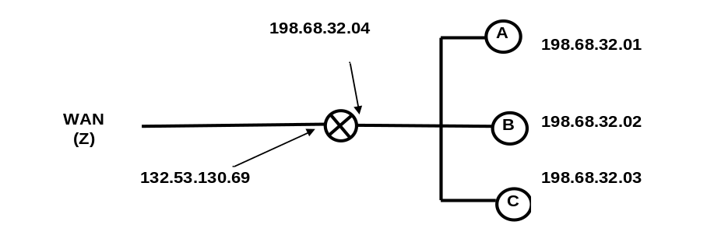
Figure 1: Simple Network with a Router Using the NAT Protocol
NAT Translation Table
WAN side address | LAN side address
132.53.130.69, 4500 | 198.68.32.01, 3000
132.53.130.69, 3250 | 198.68.32.02, 3200
132.53.130.69, 2200 | 198.68.32.02, 3000
132.53.130.69, 2100 | 198.68.32.03, 1200
… | …
Fill in the source and destination IP addresses and port numbers that will be carried in datagrams at the following four points in the network. (8 points)

 | Outgoing |  |  | Incoming
 | From B to router | From router to Z | From Z to router |  | From router to B
Source IP
Source Port
Dest. IP
Dest. Port

- Describe how DHCP works by stating the sender and purpose of each message used in the typical DHCP sequence. (8 points)
- TCP congestion control uses the number of duplicate acks and timeouts to determine the transmission rate. Assume the following events:

- Transmission of data begins at time 0 (RTT 0) with a congestion window size equal to 1 MSS (Maximum Segment Size).
- A timeout event occurs between RTT 3 and RTT 4. (adjust at 4 RTT).
- Three duplicates acks are received between RTT 8 and RTT 9 (adjust at 9 RTT).
- Positive acks received during all other RTT intervals

Write the size of the congestion window and the threshold for each RTT period in terms of MSS. The CongWin should be adjusted at the end of each RTT interval based on what happens in the interval. (12 points)

Time | Size of congestion Window (CongWin) in Maximum Segment Sizes (MSS) | Threshold in MSS
0 RTT | 1 | ∞
1 RTT
2 RTT
3 RTT
4 RTT
5 RTT
6 RTT
7 RTT
8 RTT
9 RTT
10 RTT
11 RTT
12 RTT
- Below is a portion of a routing table.

Prefix | Link Interface
11001111 00010011 1001101 | 0
11001111 00010011 10011001 | 1
11001011 00010111 00011 | 2
Otherwise | 3

- Give the Classless InterDomain Routing (CIDR) notation for the subnets identified by the first two rows of the table (for example 200.23.16.0/23). Indicate approximately how many hosts each sub-net could contain. (8 points)

CIDR notation Approx. Number of Hosts

________________________ __________

________________________ __________

- Using the destination IP addresses, determine which link interface each of the following packets should be sent to. (6 points)

Destination IP Address | Link Interface
11001011 00010101 00011000 10101101
11001111 00010011 10011011 00011000
11001111 00010011 10011001 11011101

- Fast retransmit occurs after a timeout in order to avoid an extended delay before resending a lost packet. (2 points)

TRUE FALSE

- TCP infers congestion based on “lose events” instead of using network assistance. (2 points)

TRUE FALSE

- The UDP protocol uses a three way handshake to establish a connection.
(2 points)

TRUE FALSE

- Port numbers are used by the transport layer for multiplexing and demultiplexing. (2 points)

TRUE FALSE
- Use the distance vector algorithm to update A’s forwarding table.

- Routers are identified by upper case letters i.e. A, B, C, D, E, etc.

- Subnets (destinations) are identified by lower case letters i.e. s, t, u, v, w, y, z.

- The neighbors of a router are one hop (one subnet) away.

The following is the routing table at router A:

Destination Subnet | Next Router | Number of Hops to Dest.
u | - | 1
v | B | 2
w | B | 2
x | E | 5
y | - | 1
z | E | 3
… | … | …

Assume that router A receives the following advertisement from neighbor B:

Destination Subnet | Next Router | Number of Hops to Dest.
u | - | 1
v | D | 4
w | - | 1
x | F | 3
q | R | 6

As a result of the above advertisement, A may (or may not) change its routing table. Show A’s updated routing table below: (14 points)

Please list the destinations in alphabetical order.

Destination Subnet | Next Router | Number of Hops to Dest.

- Assume the following group of IP fragments has been received. Each has a header with a length of 20 bytes.
 | Length | ID | Frag Flag | Offset
… | 740 | 99 | 1 | 0 | …
… | 740 | 32 | 1 | 90 | …
.. | 500 | 99 | 0 | 180 | …
 | 560 | 32 | 0 | 180

- Are all the fragments from the same segment? If not, how many segments.(3 points)

- Has all the data been received? If not, give the missing ranges of bytes for each of the original segments involved? (9 points)

- If some fragments of a datagram are corrupted, what will the IP protocol do with uncorrupted fragments that are received? (3 points)

- Below are four bytes of data and the 16 bit Internet checksum received in a UDP datagram. Based on this checksum, has the data been corrupted? Indicate mathematically why or why not.
(4 points)

Byte 1 | Byte 2 | Byte 3 | Byte 4 | Checksum
11100110 01100110 |  | 11010101 01010101 |  | 0100010001010011

